The Final Project's Goals
- To provide students with opportunities to practice skills relevant to the workplace.
- To provide students with opportunities to review the material we covered during the course.

- To assess students' application of the knowledge and skills taught throughout the course.
Instructions for the Final Project
  - You must complete all five parts of the project.
  - Your answers must be your own. You are not permitted to receive answers from other students or to receive assistance from an outside source. Therefore, each student will sign an honor code attesting that they worked independently on this assignment.
  - You are permitted to use personal notes and material on Moodle to assist in answering the questions. However, the answers you submit must be your own.
  - You are permitted to use Word, spellcheck, and Google Translate while answering the questions.

  - You are permitted to use AI. However, ultimately, you are responsible for checking if your answers were written according to the specific instructions for each section, and that the answers are logically in the context of the assignment. In the past, students who have relied heavily on AI have often lost points for writing incorrect answers or answers that did not sound authentic. If using AI, make sure you proofread your answers.

  - The project should be submitted as a PDF document.

Answers must be submitted by 11:59 PM. Tuesday, July 29 ((ד' באב to the submission box at the bottom of the Moodle site.

Honor Code
Please read and sign the following declaration:

I Tehila Chananayev with the I.D. # of 325435956
declare that the answers given on this assignment are my own, without receiving answers or assistance from other students, family members, or people.

The Five Parts of the Final Exam Assignment

Part 1- Resume (20 points)

Part 2- Interview (20 points)

Part 3- Presentation (20 points)

Part 4- Office Skills (20 points)

Part 5- Reflection (20 points)

Part 1/ Resumes
Part 1: Resume

- Copy and paste the resume you wrote for 8200 and submitted as your resume project.

- Rewrite this resume for one of the five companies below. Choose the company in which you are the most qualified and motivated. Read the job descriptions below of the company and then make the necessary changes and adjustments to the resume you wrote for 8200 to stress your qualifications and motivations based on the needs and desires of the company you have chosen to apply to.

Companies

Agua Farm: Software Developer (Full-Stack)
Agua Farm is seeking a motivated full-stack software developer to design and implement innovative software solutions that support our automated hydroponic farming systems. As part of a dynamic team, you will collaborate closely with cross-functional teams to improve farm management and sustainability. Strong communication and problem-solving skills are essential. Proficiency in JavaScript, Python, and cloud services is required. Fresh graduates with a passion for technology-driven agriculture are encouraged to apply.

IBM Research: Junior AI Engineer
IBM Research is looking for an enthusiastic Junior AI Engineer to join our cutting-edge research team in artificial intelligence and machine learning. This role involves contributing to AI model development, data analysis, and optimization projects. You'll need the ability to work both independently and in a team, adapting to fast-changing environments. Strong knowledge of Python, TensorFlow, and data science is essential. Recent graduates eager to collaborate and innovate in AI are welcome to apply.

Mobile Physics: App Development Engineer
Mobile Physics is hiring an App Development Engineer to build and enhance mobile applications for physics-based simulations. In this role, you'll collaborate with designers and researchers, using clear communication and creativity to bring complex concepts to life. Proficiency in both iOS and Android development using frameworks like Flutter or React Native is key. If you're a soon-to-be computer science graduate with great teamwork and adaptability skills, we’d love to hear from you.

SphereShield: Cybersecurity Analyst
SphereShield is seeking a talented Cybersecurity Analyst to help protect enterprise communication platforms from security threats. You'll work in a collaborative team environment, sharing insights and strategies to mitigate risks. Strong attention to detail, a proactive mindset, and the ability to communicate effectively are important. A strong understanding of networking, cybersecurity fundamentals, and Python scripting is needed. Recent graduates with a keen interest in cybersecurity and teamwork are encouraged to apply.

Wise Cloud: Cloud Solutions Engineer
Wise Cloud is looking for a Cloud Solutions Engineer to develop and manage scalable cloud architectures for businesses. You will design and deploy cloud infrastructures using AWS, Azure, or Google Cloud, focusing on security, performance, and cost-efficiency. The ability to communicate technical ideas clearly to both technical and non-technical stakeholders is essential, along with a proactive approach to problem-solving. Fresh graduates with cloud computing coursework and strong collaboration skills are invited to apply for this exciting role.

Grade Rubric
3-5 Keywords compatible with the applied position are well integrated in the objective of the resume: 5 points
3-5 keywords compatible with the applied position are well integrated in two other areas of the resume (hard skills, soft skills…). Alternatively, the experience section emphasis should be changed to fit the applied position: 5 points
The resume should be reviewed that it contains all the components of a professional resume (for example, in the education section, the degree, name of the college, the place of the school, the anticipated year of graduation, and sample course work should appear), including items that stress your general accomplishments and achievements (for example, in the experience section, besides for your job title, there should be a description of what you achieved). 5 points.
The resume should be proofread. Font size and font shape should be consistent throughout the resume. There should be no spelling or grammar mistakes. Words that require capital letters should be capitalized. There should be no extra bullets or spacing. Lastly, the resume should be aesthetically pleasing: 5 points
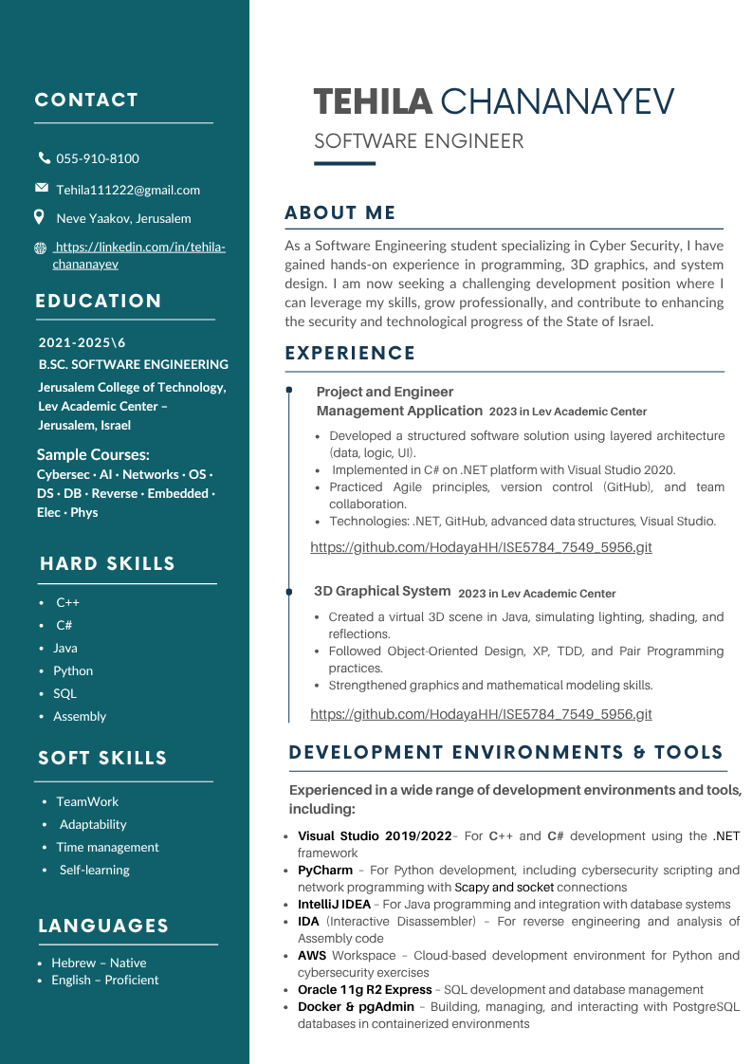
Student's 8200 Resume
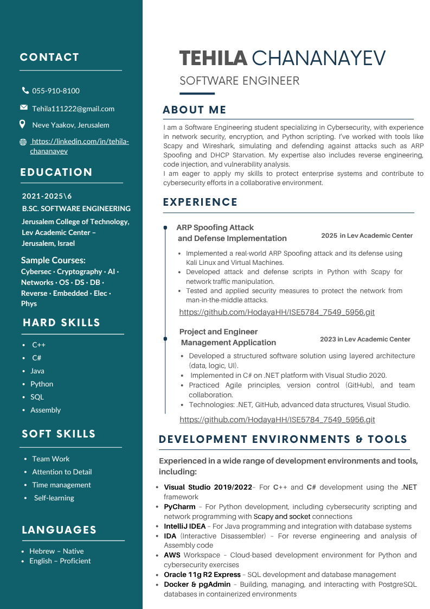
Student's Resume for Chosen Position (from the above possibilities)
Resume Adjustments for SphereShield: Cybersecurity Analyst Position
- Objective: I tailored the "About Me" section to align with SphereShield's core focus on cybersecurity. I emphasized my strong interest in the field and highlighted relevant skills that fit their needs, such as network security, Python scripting, and hands-on experience in cybersecurity projects.
- Soft Skills: In the soft skills section, I replaced some of the general competencies with specific skills that directly align with the job description, such as Attention to Detail and Collaboration. These changes reflect the company's emphasis on teamwork, attention to detail, and proactive problem-solving.
- Experience: In the experience section, I showcased a cybersecurity project I worked on that directly relates to the position. I described how I implemented and defended against an ARP Spoofing attack using Kali Linux and Scapy, highlighting both offensive and defensive network security techniques. This demonstrates my hands-on experience and my ability to apply my knowledge in real-world scenarios, aligning with SphereShield's focus on protecting enterprise communication platforms.

I also attached the resume file to the project folder.

Part 2: Interviews

Aim: To video (not on Zoom) an interview someone gives to you.
Preparations: A table, two chairs, yourself, and someone else interviewing you.

- You, the student, are the Interviewee.

- The other person (a relative, classmate, or friend) is the interviewer.

The interviewer, representing the company you chose to send your resume to (in part #1 of the assignment), will interview with you, in English.

In addition, there will be a third person who will film the interview. Alternatively, you can use a sophisticated camera to film the interview.

The interviewer will ask you the following seven types of questions: (NOTE: When answering the questions, follow the instructions of each question)

- "Tell me about yourself" question (The answer should include (in the following order) your current academic status, your past accomplishments, and your future professional vision). (2 points)

- Skill question (The answer should include a story demonstrating your skill and showing your passion for it). (2 points)

- Self-Knowledge question (The answer should contain only positive items about yourself. It should also include a detailed story). (2 points)

- Behavioral question about a past experience (The answer should have details, be interesting, and show your good qualities). (2 points)

- Situational question about a potential future situation (The answer should show your communication skills, as well as show multiple possibilities of what can occur and therefore multiple solutions ("if this solution didn't work, I would do…")). (2 points)

- Curve Ball Question (The answer should reflect creative thinking, as well as speak about the values the company promotes). (2 points)

- "Do you have any questions for me?" Two questions should be asked of the interviewer, which show your enthusiasm and interest in being hired by the company. In addition, comments should be made on the received answers of the interviewer with enthusiasm and eagerness. (2 points)

Further Instructions

- The interviewee needs to sound authentic. Therefore, one should practice saying the answers a number of times prior to the interview (it is recommended to practice at least five times) so the answers will be said smoothly, authentically, and clearly. (2 points)

- The interviewee should dress well for the interview. For men: A button-down shirt and long pants. For women: A formal outfit. (2 points)

- The interviewee must show enthusiasm for the position, as well as confidence throughout the interview. (2 points)

- The entire interview needs to be conducted in English without any Hebrew words. The use of three or more Hebrew words during the interview will disqualify the interview, and it will not receive any points.

- The interviewee can not use a script. An interview read from a script will not receive any points.

- The interview must be heard clearly. If the interview is not heard on the video, the interview will not be graded, and it will not receive any points.

- Provide a working link to your recorded interview using your Google Drive JCT account. Make sure you open it for viewers. You can also link with WhatsApp or by making a YouTube video.

- Remember to smile during the interview

Link to your interview:

https://drive.google.com/file/d/1b0Zi5lbWGAZbpL_GSOmPiypR1XuQ5dRH/view?usp=sharing

Part 3: Presentation

Aim: To make a 5–7-minute presentation on any topic you desire (this can be done by video or Zoom).
Pre-Presentation Instructions (1 point)
- Write down the topic you will be presenting on. Here are some tips when choosing a topic:
- Choose a topic you're already familiar with. This will cut the time you spend researching your topic.
- Keep it simple. Avoid complex topics that need lots of explanation. If a topic is complex, pick a single, simple aspect of it to present on, rather than trying to cover it all.
- Stick to one or two main points. Also limit yourself to a minimal number of sub-points. Because your presentation length is limited, it's unlikely you'll have time for more than that.
- Remember your audience's background. I can't say this enough—to create an engaging presentation you must know your audience.

Topic of Your Presentation: _Social Network Analytics
__________________________________

- Write down three to five facts about the audience you will be speaking to. (1 point) THE REASON: To make sure that you reach your audience with material that they can understand and relate to, you need to know as much about them as you can. Also, with only five minutes for your presentation, you don't want to waste time covering information your audience already knows.

- They are interested in investments.

- They are mature and experienced people.

- They are smart and intelligent.

- They have strong connections with the right people.

- They have a lot of money

- Choose one of the following six presentation goals as the goal for your presentation. (1 point)

  - To inform (i.e., to inform the audience of facts about something new).

  - To educate (i.e., to teach the audience a new perspective about a topic they already know about).

  - To persuade or convince (i.e., to cause them to believe or buy something).

  - To activate (i.e., cause them to take a specific action).

  - To inspire or motivate (i.e., to make people think, move, or change their behavior).

  - To entertain (i.e., to give the audience a good feeling).

Your Goal: __C. To persuade or persuade - To make them invest_______________________________________________

- List 8-10 presentation phrases https://www.fluentu.com/blog/business-english/business-english-presentation-phrases/ you will use during the presentation. (1 point)

Good afternoon

First, let me introduce myself

Let's start with a surprising facts

In other words

To put it simply

Now we are going to show you

This is an excellent example

We found that there

In conclusion

Thank you for your attention today.

We hope that you have enjoyed

5.List 8-10 positive words https://www.presentationmagazine.com/top-positive-words-presentation-16762.htm you will use during the presentation. (1 point)

learn

a lot

found

excellent

wonderful

Thank you

enjoyed

show

Components of the Presentation

- Each presentation must start by introducing yourself. State your name and explain what you do or who you represent at the start of the presentation. (Alternatively, you can start with the Hook section (step #7) and after that present yourself). (2 points)

- The Hook (you must get your audience's attention, for example, using a question or something surprising, that will create interest in your presentation topic). (2 points)

- "Tell them what you are going to say" (Explain to the audience 2-3 ideas you are planning to speak about in this presentation). (2 points)

- "Say it" (Present the information in a clear and organized way. In addition, examples should be used to illustrate the ideas). (2 points)

- "Tell them what you just said" (Summarize the main points you spoke about during the presentation). (2 points)

- Personal Story (The story should reflect the ideas you wish to convey). (2 points)

Further Instructions

- The presenter must show enthusiasm and confidence throughout the interview. (1 points)

- The presenter needs to sound authentic. Therefore, one should practice the presentation (it is recommend practicing at least five times) before saying the presentation. This will make the official presentation come across sounding more authentic. (1 point)

- The presenter should dress well. For men: A button-down shirt and long pants. For women: A formal outfit. (1 point)

Additional Instructions

- The entire presentation needs to be conducted in English without any Hebrew words. The use of three or more Hebrew words disqualifies the presentation, and it will not receive any points.

- The presentation cannot be read from a script. A presentation read from a script will not receive any points (However, an occasional glance at notes is permissible).

- The presentation must be heard clearly, and eye contact needs to be made with the camera. If the presentation is not heard on the video, or the presenter is not facing the camera, the presentation will not be graded, and it will not receive any points.

- Like in the interview, remember to smile during the presentation

Place a link to your recorded presentation (using your Google Drive JCT account) here. Make sure you open it for viewers. Other ways to send the link to me are through your WhatsApp, Zoom recording, or by making a YouTube video.

Link to your presentation:

https://drive.google.com/file/d/1b7IfolRhujE35nP8dTU7ZXRvwSs-AXKQ/view?usp=sharing

I have attached the presentation named Presentation project English-part 3 and the text Presentation project English-part 3 and the recording of the presentation in presentation-good in the project folder.

Part 4/Preparing for the following company meeting:
Read the agenda for the upcoming meeting:

TELABELA COMPUTERS MONTHLY meeting
Agenda for JULY's MEETING
Where: In the main meeting room. | When: Tuesday, July 29th
Time: 9:00 AM-11:30 AM | Who should attend: All employees of TELABELA COMPUTERS.

Agenda Items
- Welcome and introductions (5 minutes)
Topic of the meeting: Discussion on the new project being worked on: The development of pleasant alerts during missile attacks.
- Team Updates (30 minutes)
- Programmers: Explain the new software being designed for the pleasant alerts.

- Data Analysts: Explain the trends in data in the field, analyzing the need for pleasant alerts during missile attacks.

c. Web developers: Explain the recent tests and debugging of the pleasant alerts program.

- New Business (45 minutes)
a. Listening to the company's idea to introduce Generative AI at Telabela https://www.sas.com/en_us/insights/analytics/generative-ai.html .
- Open Forum (45 minutes)
a. Discussion and critique of the proposed policy to use Generative AI at Telabela.
- Action Items and Next Steps (20 minutes)
a. Distribution of Tasks
b. Follow-up timetable.
- Adjournment (5 minutes)
a. Accessing what still needs to be discussed at the next meeting.
b. Announcing when the next meeting will take place.
You must prepare for the following four parts of the meeting:
Preparation for Team Updates (section #2 of the meeting) (5 points)

- There will be three teams speaking at this section of the meeting (see the above agenda). Write which of the three teams you wish to be in: a) programmers, b) data analysts, c) web designers: ____
a) programmers
- Prepare a visual component to accompany the team update on the development of pleasant alerts during missile attacks, according to your team's update. The visual can be 2-4 slides, 2-4 diagrams, or a 2–4 minute video.

Items to do when making the visual
1)The visual should help clarify the message of your update.

2) The visual should be easy to understand.

3) The visual should be aesthetically pleasing.

Items not to do when making the visual
1) Focusing on the wrong elements: Your visual needs to help support the main message of the update, rather than minor points.
2) Using excessive graphics: Too many graphics can be overwhelming and confusing.
3) Using graphics incorrectly: People often don’t pay attention to the rules of design. This can make the visuals confusing or unpleasant to view.
Link to the visual component: I attached the presentation called Team_Programmers-part 4 to the project folder.

Preparation for New Business (section #3 of the Meeting) (5 points)

The company has proposed to introduce Generative AI at Telabela. Before the meeting, research the idea and formulate an opinion on it.

  - Research the idea of Generative AI
Suggested Sites to Research
https://news.mit.edu/2023/explained-generative-ai-1109

https://campustechnology.com/articles/2025/02/21/study-generative-ai-could-inhibit-critical-thinking.aspx

https://wiobyrne.com/generative-ai-as-critical-friend/

  - Prepare your thoughts on this topic by completing the PMI chart on this new feature, based on the research above.

THE QUESTION | Pluses | Minuses | Interesting | Decision
To introduce Generative AI into the company. | - Can save time on repetitive tasks  - Helps generate creative content  - Improves productivity and customer support | - May reduce critical thinking - Risk of errors or bias in AI output - Employees might feel replaced | - Some companies use it as a "critical friend" to improve decision-making - Could change the way teams collaborate | Yes – with clear policies and training for employees
Preparation for Open Forum (Section #4 of the Meeting) (5 points)

- Write a 4-6 sentence paragraph of the speech you will say at the meeting, presenting your opinion on the introduction of Generative AI to the company. The paragraph should integrate the information you researched, summarized in the above PMI chart. The paragraph needs to be written with correct grammar, spelling, punctuation, and capitalization.

When speaking, keep in mind that an important goal of speaking at a meeting is to increase your visibility to your colleagues and managers. Therefore, incorporate these three steps in your talk:

- Start by introducing yourself to the people of the meeting by saying who you are and what your role is at the company.

- Address items or issues that are "Elephants in the Room," items or issues that everyone will be aware of their importance.

- Bring numbers to prove your point.

Your Paragraph

Good morning. My name is Tehila Chananayev, and I am a programmer at Telabela Computers.
One important issue we all recognize is the growing influence of AI in the tech world — and ignoring it is no longer an option.
According to MIT, Generative AI can boost creativity and help automate routine tasks, saving up to 30% of work time in some roles. However, we must also be careful about over-reliance and make sure employees are trained properly. With the right framework,
I believe Generative AI can help our company grow and innovate.
I fully support introducing it — with responsibility.

Preparation for Action Item (Section #5 of the Meeting) (5 points)

- You should volunteer for a task in this section of the meeting. Choose one of the following three tasks that is fitting for your personality and skills:

- Sharing with all the participants organized and accurate minutes of the meeting.

- Creating action items and ensuring they are tagged with owners.
- Being responsible for following up to ensure clear accountability of tasks.

Your Choice: 1, 2 or 3. _2___

- Write a follow-up email to all the participants of the meeting. The email should explain to the participants the task you have chosen and how you wish to accomplish it. The email should contain a link to a Google Docs or another tool that enables you to do your task. The link should be a working link. Use a polite and professional tone throughout the email. In addition, the email needs to be written with correct grammar, spelling, punctuation, and capitalization.

YOUR email

Subject: Action Items – Follow-Up from July Monthly Meeting

Dear Team,

Following our meeting on July 29th, I have volunteered to manage the action items from today’s session. I’ve created a shared Google Sheet to organize all tasks and assign clear ownership to each one.

Please review the document and confirm your assigned responsibilities by the end of this week.

https://docs.google.com/spreadsheets/d/1UhzGGqm34B8hal9NtO-8-w-NFiEWKVicSu-upT8Un2I/edit?usp=sharing

Let me know if you have any questions or need to update your task.

Best regards,
Tehila Chananayev
Programmer, Telabela Computers

Part 5- Reflection
Answer these 8 questions, based on material we learned in class or that is on the Moodle site of the Computer English course (articles and videos on the site or in the resources). Answers that are not based on items we learned in class or do not appear on the Moodle site will not receive credit.

- List three new items you learned from the "Resume Unit". Which of these three items do you feel is the most useful and why? (3 points)

1. Match the Job Description Keywords
- Why it's useful: Many companies use automated systems to filter resumes. By using keywords from the job description, your resume is more likely to pass these filters and be seen by a recruiter.
2. Include Links to Your Professional Online Presence
- Why it's useful: Including links to your LinkedIn, GitHub, or portfolio can show employers your skills and past projects, making your resume stand out in a competitive field.
3. Quantify Your Achievements
- Why it's useful: Instead of saying “managed a team,” quantifying your achievements with numbers (e.g., "increased sales by 20%") shows employers the real value you can bring.

Most Useful: Match the Job Description Keywords
- Why: This is the most important because it ensures your resume gets past automated filters and reaches a recruiter. If your resume matches what the employer is looking for, you have a better chance of landing an interview.

- List three new items you learned from the "Interview Unit". Which of these three items do you feel is the most useful and why? (3 points)

- How to Answer "Tell Me About Yourself"
This question is often asked at the start of interviews. It’s important to keep your answer short, professional, and focused on your skills and achievements. It’s your chance to set a positive tone, including your current academic status, past accomplishments, and future goals.
- How to Handle Behavioral and Situational Questions
I learned that answering with real-life examples makes your answers more credible and helps show how you handle challenges, work under pressure, and collaborate with others.
- The Significance of the Post-Interview Thank-You Email
Sending a thank-you email after the interview is crucial. It shows gratitude, reinforces interest in the position, and leaves a good impression.

Most Useful: How to Answer "Tell Me About Yourself"
This question is asked in almost every interview, so being prepared with a strong, concise answer is essential. It sets the tone for the rest of the interview and gives you the chance to highlight your skills and experience right away.

- List three new items you learned from the "Presentation Unit". Which of these three items do you feel is the most useful and why? (3 points)

- The Importance of Visuals
Each slide should have a visual element (like pictures or charts) to help the audience better understand and remember what is being said. Visuals make presentations more engaging and memorable.
- Reviewing Slides for Errors
It's important to have someone review your slides before presenting to check for grammar and spelling errors, as well as to suggest improvements. This ensures a professional and polished presentation.
- Minimal Text on Slides
Don’t crowd your slides with too many words. Only include a few words or none at all, focusing on visuals instead. Too much text can distract the audience.

Most Useful: The Importance of Visuals
Visuals help reinforce the spoken content and make the message clearer and more memorable. Using appropriate images enhances the audience's engagement and understanding of the presentation.

- List three new items you learned from the "Office Skills Unit". Which of these three items do you feel is the most useful and why? (3 points)

- Active Listening Techniques
I learned techniques like giving full attention, showing I'm listening through body language, providing feedback, and deferring judgment. These techniques help improve communication and understanding.
- Verbal Communication Skills
I learned the importance of being friendly, thinking before speaking, being clear, and speaking concisely. These skills are essential for effective communication.
- Non-Verbal Communication Skills
I learned how body language, facial expressions, eye contact, and posture can convey messages and support verbal communication.

Most Useful: Active Listening Techniques
The most useful for me is learning how to listen actively. It helps me understand the other person better and avoid misunderstandings.

- List two new items you learned from the "Problem-Solving Unit". Which item do you feel is the most useful and why? (2 points)

1.Simplifying the Problem
Breaking down a problem into smaller, more manageable parts helps in understanding it better and makes it easier to solve.

2.Taking Breaks
Stepping away from a problem when frustrated allows the mind to reset and come back with a fresh perspective.

3. Writing Down Your Thoughts
Writing down the specific steps you're trying to take or the issues you're facing helps clarify your thought process and keeps you focused on solving the problem.

Most Useful
Simplifying the Problem is the most useful technique. It helps me focus on one small piece at a time, reducing overwhelm and making the overall problem less intimidating.

- List two new items you learned from the "Conflict management". Which item do you feel is the most useful and why? (2 points)

- Active Listening is Crucial
One thing I learned is how important active listening is when dealing with conflict. It's not just about hearing the other person, but really understanding their point of view. This helps in finding a solution that works for everyone.
- Different Conflict Resolution Techniques
I learned that there are five main conflict resolution techniques: avoiding, accommodating, competing, compromising, and collaborating. Depending on the situation, you can choose the best approach to handle the conflict.
- Glaser’s Three-Step Strategy
I also learned about Glaser's three-step strategy for conflict resolution: first, identifying the problem, then exploring possible solutions, and finally agreeing on a solution. It’s a good way to approach conflicts in a structured manner.

Most Useful:
I think the most useful was active listening, because it really helps in understanding the problem better and makes it easier to find a solution that everyone can agree on.

- List two new items you learned from the "Email Unit". Which item do you feel is the most useful and why? (2 points)

- The Importance of a Clear Subject Line
I learned that the subject line in an email is crucial because it can determine whether the email will be opened or ignored. A good subject line sets expectations and ensures the email doesn't land in the spam folder.
- Using Concise Text and Proper Formatting
I discovered that it’s important to keep the text concise and easy to read. Most people skim emails, so it's best to avoid unnecessary words and break the email into short paragraphs. Using bullets or numbered lists also helps make the email more readable.
- Responding in a Timely Manner
I learned that it's important to respond to emails quickly, Prompt responses help keep work on track and maintain smooth communication.

Most Useful:
The most useful tip for me was using concise text and proper formatting. This helps me communicate more clearly and saves time for everyone involved.

- Fill out a PMI chart rating the entire "Computer English" course (2 points).

Topic | Pluses | Minuses | Interesting | Overall Rating (a number from 1-10)
Computer English Course | I learned a lot from the course that helps in life and in my career.  Improved technical vocabulary and expressions from the tech world.  Helps better understand English in professional settings. | It was a bit challenging, the assignments are long and tiring.  There’s a feeling of repetition on some topics. | Yes, it helps improve communication skills in English in a tech environment. | 8

To succeed, follow all of the instructions of the project.

If you have questions about the project, let me know.

Avraham Norin
052-479-9319
norin@g.jct.ac.il

All the best!!!
בהצלחה!!!

Answers must be submitted by 11:59 PM. Tuesday, July 29 ((ד' באב to the submission box at the bottom of the Moodle site.

